# CREATE A SIMPLE WEB APPLICATION USING JAVA OR PYTHON

**STEP – 1:**

Create a new web application.

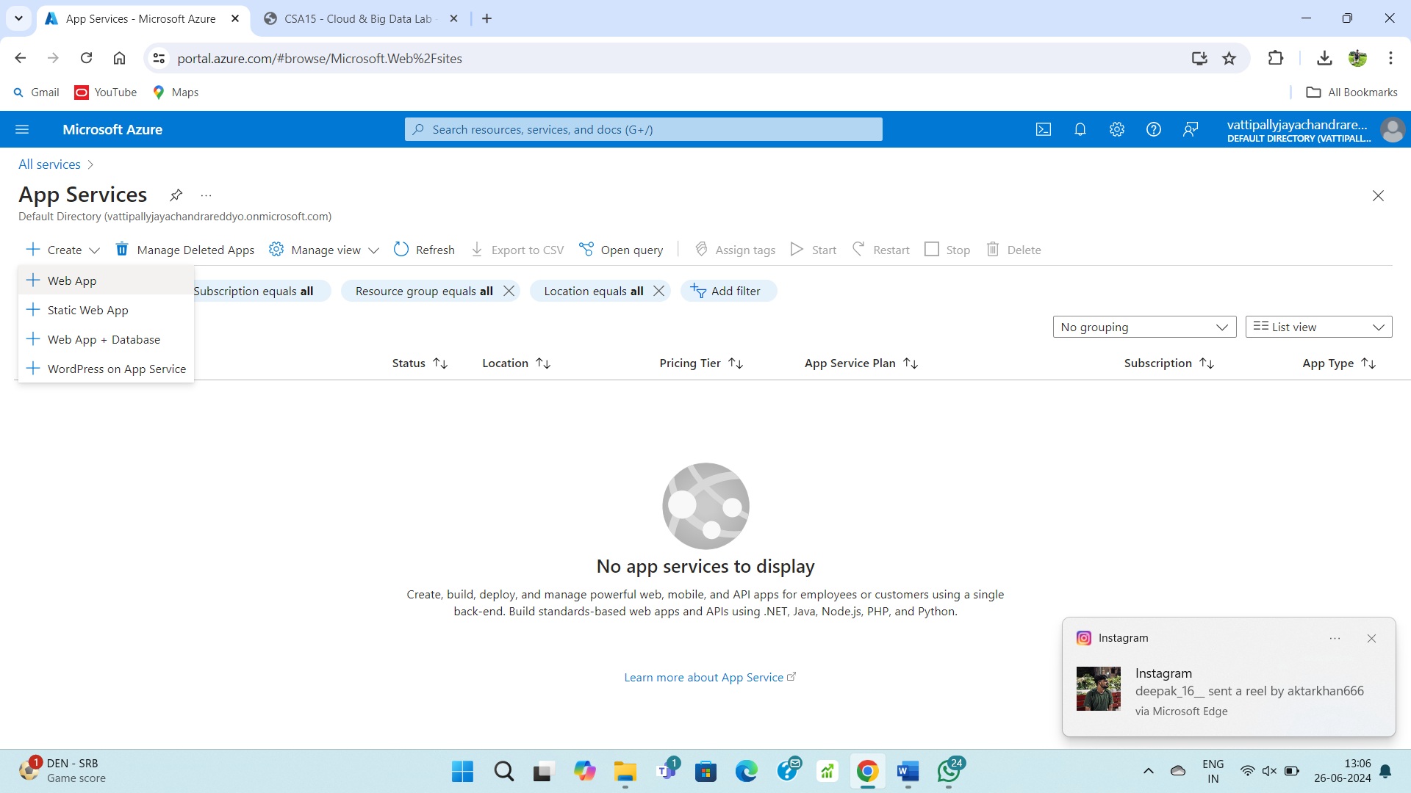

**STEP – 2:**

Fill upon the form basics.

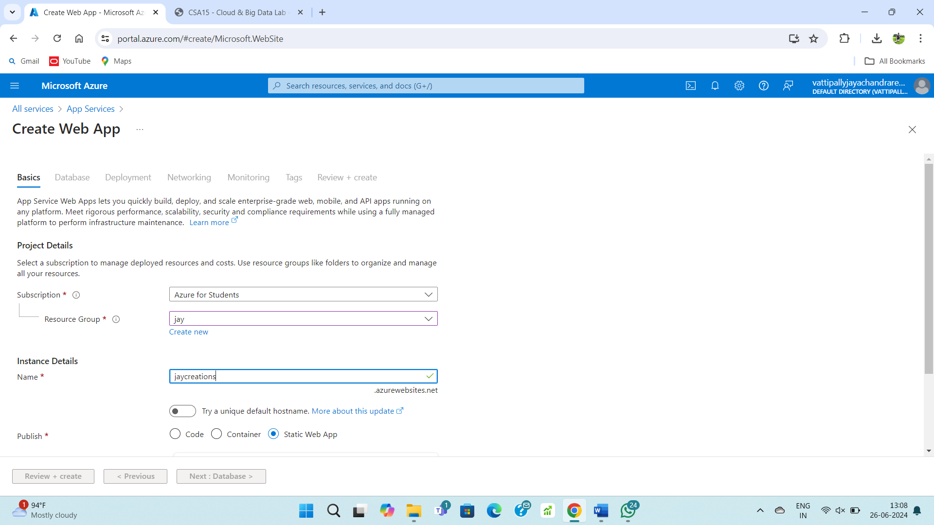

**STEP – 3:**

Fill upon the database form.

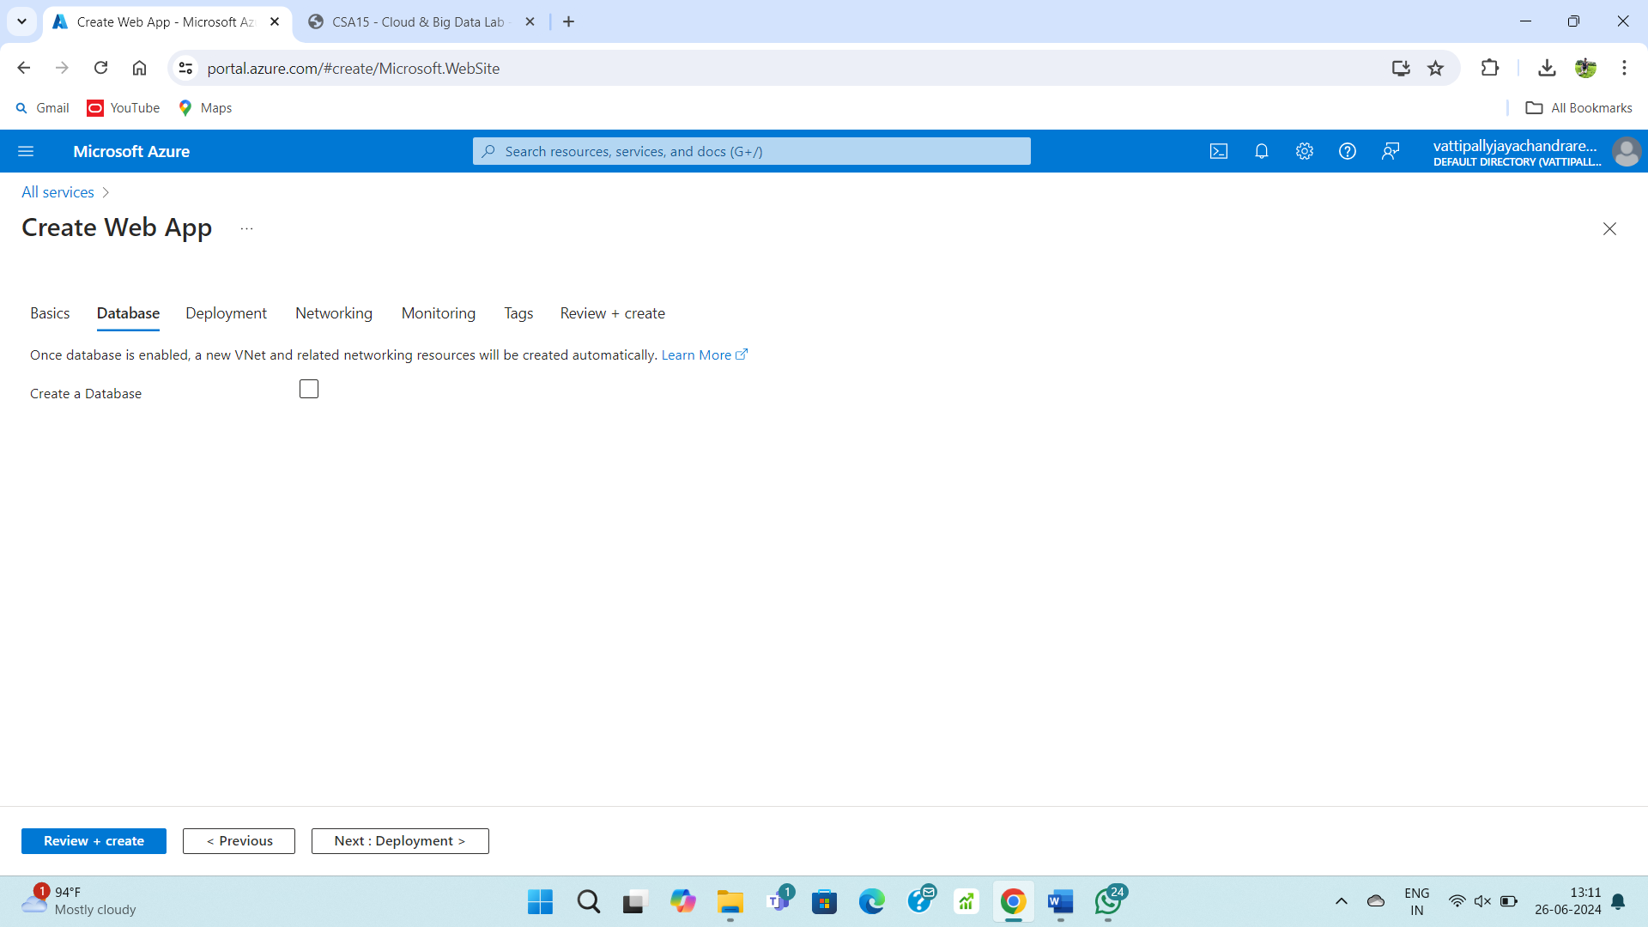

**STEP – 4:**

Fill upon the deployment form.

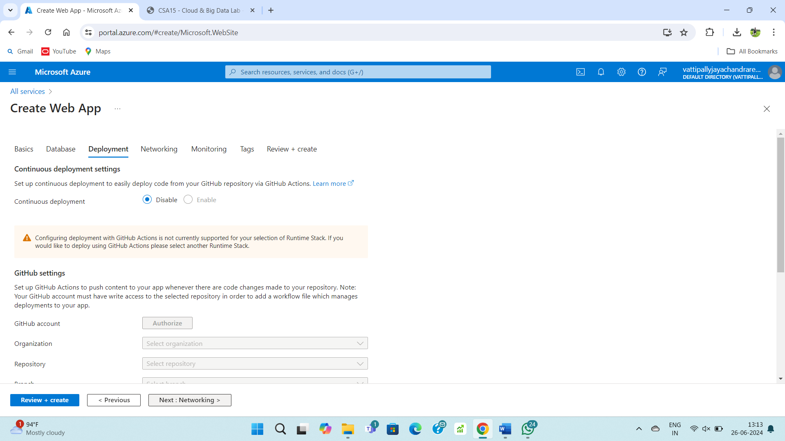

**STEP – 5:**

Fill upon the networking form.

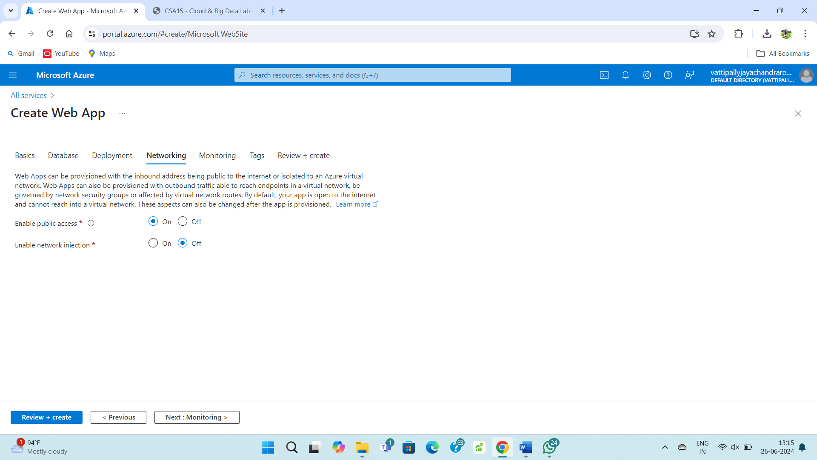

**STEP – 6:**

Fill upon the monitoring form.

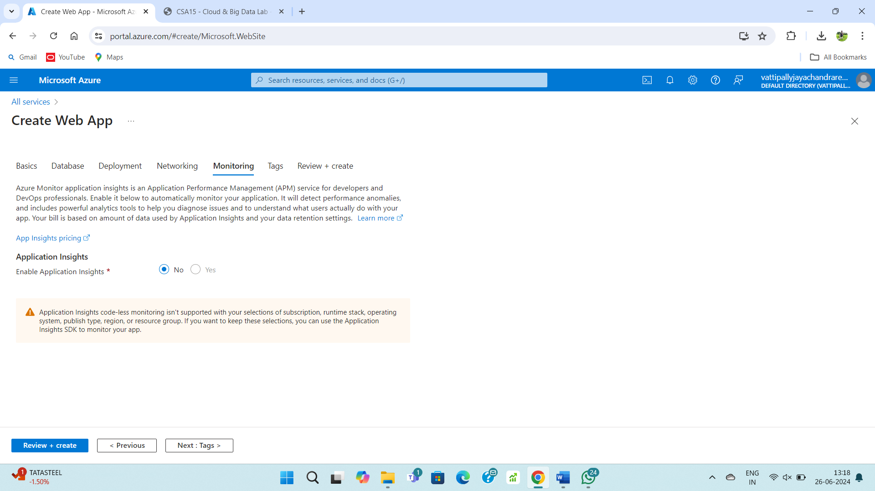

**STEP – 7:**

Fill upon the tags form.

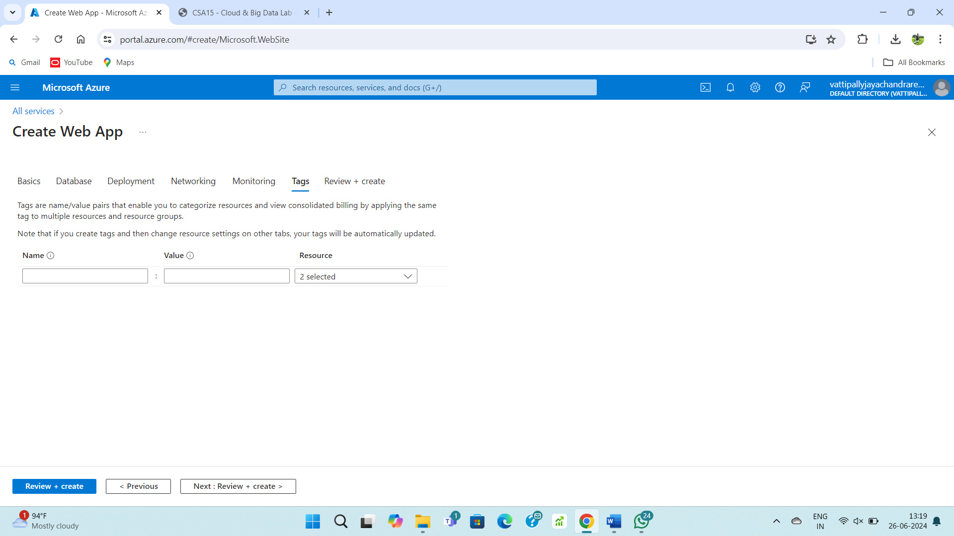

**STEP – 8:**

Review and create the web app.

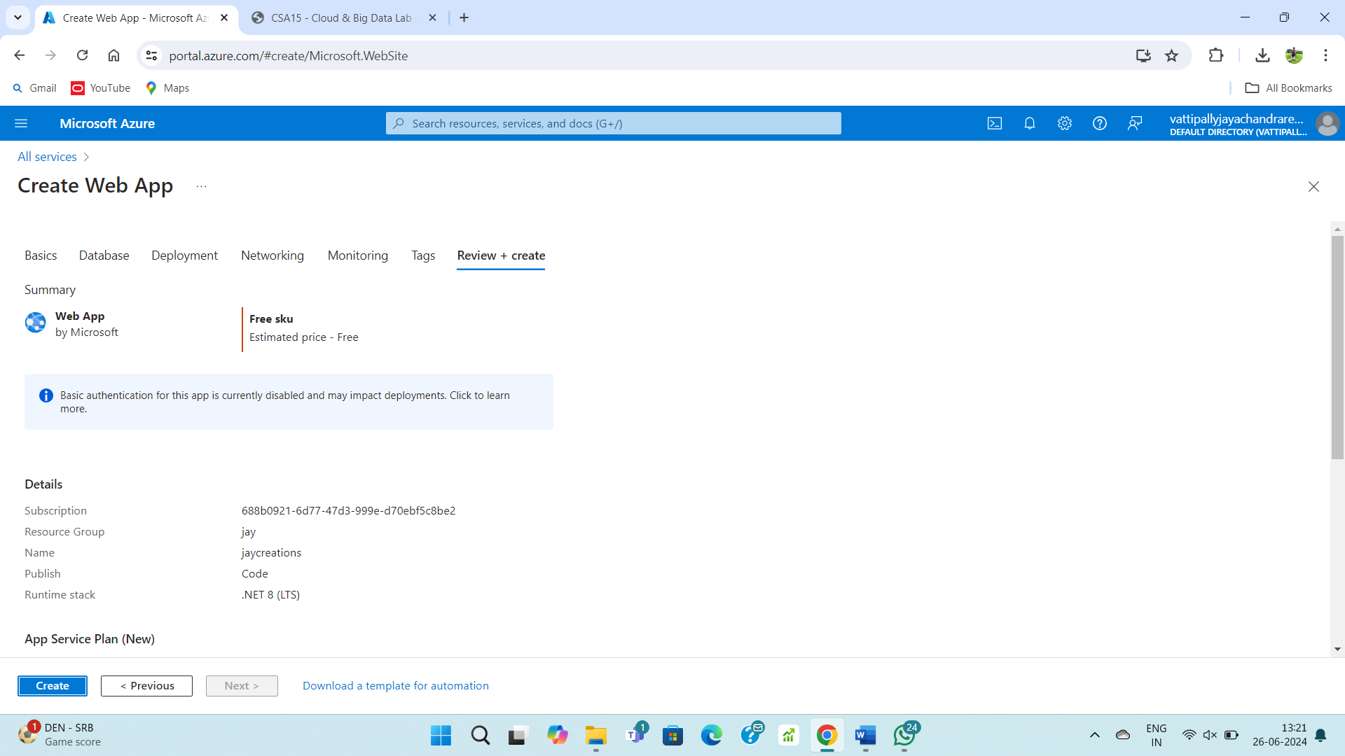

**STEP – 9:**

After completion of deployment your web.

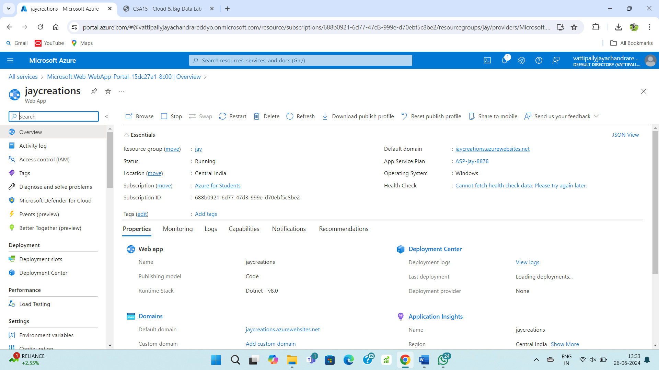f